F


Future Technologies Industry Cluster
College of Vocational Education
Associate Degree in Information Technology AD006
COSC 2383 Advanced Networking 2
Case Study ANSWER SHEET
Semester 1 2024
This assessment task is worth 30% of your total grade
Name: __________________
Student number __________________
Instructions.

Your points score for this task will be scaled to a Canvas assessment score out of 29

*You must submit this sheet and your Packet Tracer file by the due date
Friday May 3, 5.30pm

*Download the Packet Tracer file from the Assignments section on Canvas.
PT Adv Net 2 CS sem 1 24 initial.pkt

*use your eJournal, class labs and any other internet resource, including chatgpt. But you cannot discuss your work with other students. You may ask for guidance from your teacher, preferably using email

*Rename this word document with you name and student number.
*Type your name at appropriate place above

Note: You only need to submit this answer sheet with your answers on Canvas.
No need to submit the PT file
The PT file is provided for you to test your commands, if you choose

Task 1 Switch Port Analyzer (SPAN) on the main topology
Write the commands. It is optional to test on your PT file
- Configure local SPAN on Sw2 to monitor only ping and secure web (normal and secure browsing) frames coming in or going out of the port connected to the Main_Server on port 10.
Task 1 Be careful to paste the commands under the correct heading

A Local SPAN Sw2
monitor session 1 source interface FastEthernet 0/10
monitor session 1 destination interface FastEthernet 0/2
!small screenshot of sniffer settings

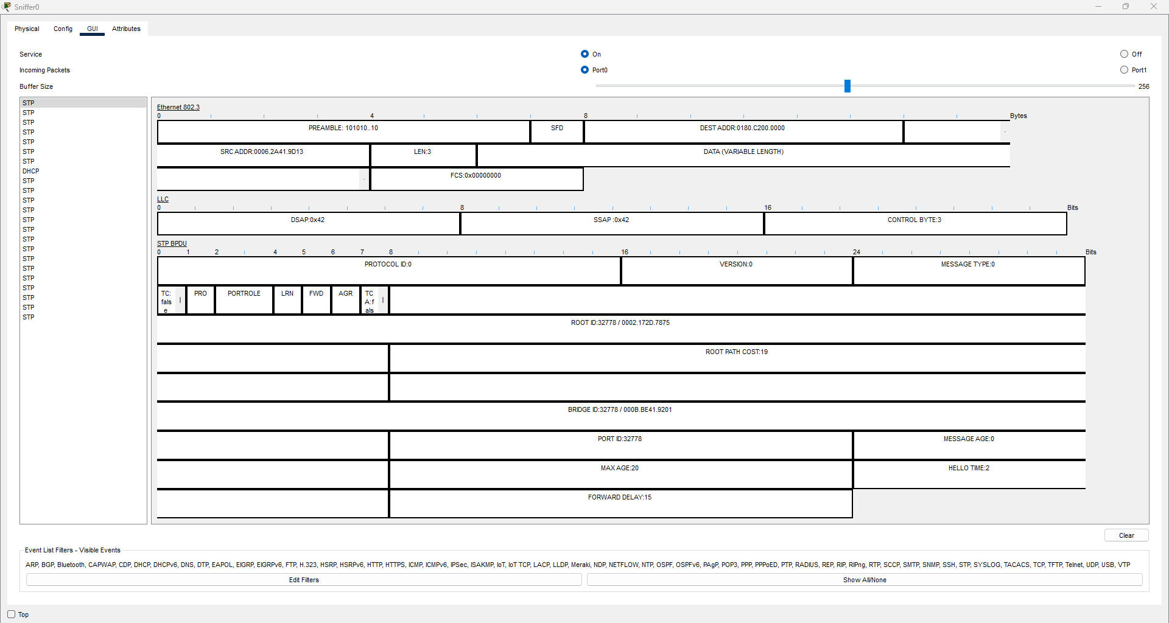
D RSPAN
!Sw1, Sw2
vlan 350
remote-span
!Sw1
monitor session 2 source interface FastEthernet 0/18
monitor session 2 destination remote vlan 350
!!
!Sw2
monitor session 2 source remote vlan 350
monitor session 2 destination interface FastEthernet 0/2

- Configure RSPAN commands on Sw1 and on Sw2 so that any frames sent out of Sw1 port 18 will use vlan 350 to be sent across the trunk link to be captured by the sniffer on Sw2 (port 2)

Task 2 Troubleshoot IVR on a router, IVR on an MLS, EIGRP
on the main topology
Write the commands. It is optional to test on your PT file
- Vargas router has been correctly configured with subinterfaces for VLANs 10 and 20. However PC6 (VLAN 10) cannot ping PC8 (VLAN 20)
Troubleshoot and fix any problems => write or show what you did to fix the problem
- Configure the MLS, called DLS1, so that it has a VLAN 20 address that uses the 2nd last address in the VLAN 20 subnet. Make sure that this interface is up.

- Configure EIGRP on DLS1 so that all active interfaces are enabled for EIGRP.
Use a single eigrp network statement to achieve this.

- Modify the eigrp configuration on the Merida router so that it is an eigrp neighbor of the DLS multilayer switch. Only enable EIGRP on the Merida link to DLS not on the other Merida interfaces
Task 3 Etherchannel on the main topology
Task 2
A Troubleshoot IVR between PC6 and PC8
interface fastethernet 0/0.10
encapsulation dot1Q 10
ip address 172.1.10.1 255.255.255.0
no shutdown
interface fastethernet 0/0.20
encapsulation dot1Q 20
ip address 172.1.20.1 255.255.255.0
no shutdown
interface fastethernet 0/0
no shutdown
B MLS = DLS1
interface vlan 20
ip address 172.1.20.254 255.255.255.0
no shutdown
C EIGRP on DLSw
Router eigrp 1
No au
router eigrp 1
network 172.1.0.0
no auto-summary
D EIGRP on Merida
Router eigrp 1
No au
network 172.1.10.0 255.255.255.0
passive-interface default
no passive-interface fastethernet 0/0
no auto-summary
- Configure a layer 3 etherchannel group 43 between Sw3 and Sw4 for their connected ports fa0/1 and fa0/2. Use a standards based protocol.

- This layer 3 channel belongs to the network 172.1.100.48/30. Show the addressing on Sw3 only
- On Sw3 and Sw4 enable OSPF on this network 172.1.100.48/30 but don’t use any ospf network command (i.e. use an OSPF technique that does not use an ospf network statements).
- Load balance using source mac address
Task 3 Be careful to paste the commands under the correct heading
Write the commands. It is optional to test on your PT file
A Sw3,Sw4 L3 etherchannel, gp 43, standards based
interface range fastethernet 0/1 - 2
no switchport
channel-group 43 mode active

B ip addressing 172.1.100.48/30
!Sw3 ip addressing
interface port-channel 43
ip address 172.1.100.49 255.255.255.252
no shutdown
C Sw3,Sw4 ospf
ip routing
router ospf 1
passive-interface default
no passive-interface port-channel 43
D Sw3,Sw4 Load balancing
port-channel load-balance src-mac

Task 4 Dot1x authentication on the main topology
Write the commands. It is optional to test on your PT file
One valid dot1x credential uses a username of Leonardo52 and a password of
Cisco57-6-01
- Configure Sw1 so that any user on Sw1 PC6 (port 9) needs to be authenticated using dot1x services from the Main_Server (172.1.10.100). Assume the AAA password on the server is correct.
- Sw1 may also use a backup aaa server at 172.1.10.101 (this server is not shown on the PT file). This backup server uses the same key as the Main_Server for the client Sw1 Write what needs to be done on this backup server to be ready to authenticate dot1x clients if the Main_ Server at 172.1.10.100 fails.
- Also, configure Sw1 to use this backup server.
- Setup PC6 to successfully authenticate using dot1x
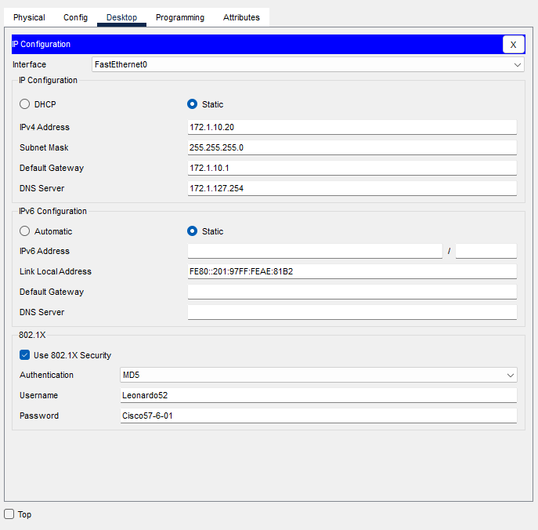
Task 4 Be careful to paste the commands under the correct heading
!A Sw1 commands to enable aaa and dot1x to use a main server at 172.1.10.100; there is a PC6 on Sw1 port 9
!aaa new-model
aaa authentication dot1x default group radius
radius-server host 172.1.10.100 key Cisco57-6-01
dot1x system-auth-control
interface fastethernet 0/9
switchport mode access
dot1x port-control auto
!B In the space below, write what actions needed to be done on the Backup_server
Ensure RADIUS Service is Running
Use the Same Key: The backup server needs to use the same shared secret key.
Correct Client Configuration.
! C write the command on Sw1 for a backup server
radius-server host 172.1.10.101 key Cisco57-6-01
!D In the space below, paste a small screenshot of the dot1x settings on PC6 should be Leonardo52 and 57-6-01

Task 5 DHCP inside the cloud called DHCP
Write the commands. It is optional to test on your PT file

Task 6a ipv4 DHCP on an MLS
A MLS_DHCP is already configured with a DHCP pool for VLAN 20 devices.
Do further configuration on MLS_DHCP so that dhcp works for this VLAN 20 pool
If you decide to configure your PT file, you may test this DHCP service on the VLAN 20 PCs
Task 6b ipv4 DHCP on a server
B The Internal_Server is preconfigured with a DHCP pool is for local clients. Modify the server settings so that Cisco VoIP phones may obtain the address of a server at 172.10.1.10. Wireless access points need to obtain the address of their LAN Controller at 172.10.1.20 Use a screenshot to show the new settings

Task 5c ipv6 DHCP autconfig and stateless configuration
Task 5a Be careful to paste the commands under the correct heading

A MLS_DHCP Add configuration to MLS_DHCP

ip dhcp pool VLAN20
network 172.1.20.0 255.255.255.0
default-router 172.1.20.1
ip dhcp excluded-address 172.1.20.1 172.1.20.10
interface vlan 20
ip address 172.1.20.1 255.255.255.0

B ipv4 DHCP on a server

Task 5b Small screenshot of the Server settings => Replace the screenshot below with your screenshot
A

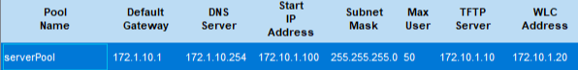
Write the commands. It is optional to test on your PT file

- Ensure that only autoconfig is available for PCs14 and 15
- Configure Router_DHCP so that the PCs connected to fa0/0 on the router will obtain ipv6 addresses using stateless dhcp
The PCs should receive the dns address of 2001::210 and the domain name of cisco2024.com (use the pool name STATELESS_DHCP)
Task 5c Be careful to paste the commands under the correct heading

!Router_DHCP only autoconfig for PCs 14, 15
ipv6 unicast-routing
interface fastethernet 0/1
ipv6 address autoconfig
no shutdown
! B Router_DHCP configure stateless ipv6 dhcp
ipv6 dhcp pool DHCPv6_Pool
dns-server 2001:4860:4860::8888
interface fastethernet 0/0
ipv6 nd other-config-flag
ipv6 dhcp server DHCPv6_Pool
no shutdown

Task 6 HSRP inside the cloud called HSRP
MLS-hsrp and R-hsrp are in a HSRP group 20, for vlan 20 devices
R-hsrp and MLS-hsrp already have some hsrp configuration.
Complete the hsrp configuration on R-hsrp int fa0/1 so that…
- R-hsrp is the Active HSRP device
- failover time is faster by changing the hsrp timers on R-hsrp to a Hello 2 second and hold-time 6 seconds
Modify configuration on MLS-hsrp so that
- hsrp works as expected
- packets from the PCs going to the server use the serial link between R-hsrp and R2-hsrp.
- Write or show with a screenshot what needs to be done to ensure that the PCs are ready to use HSRP
Task 6 HSRP Be careful to paste the commands under the correct heading
! A Complete the R-hsrp HSRP settings
int f0/1
standby 20 ip 172.16.100
standby 20 priority 150
standby 20 preempt
! B modify timers
Int fa0/1
standby 1 timers 2 6
! C complete hsrp on MLS-hsrp
!on MLS-hsrp
Int vlan 20
standby 20 ip 172.16.20.100
standby 20 priority 100
standby 20 preempt
! D packets must use the serial link when R-hsrp is active
ip route 10.1.30.0 255.255.255.0 Serial 0/0
! E pcs are ready to use HSRP

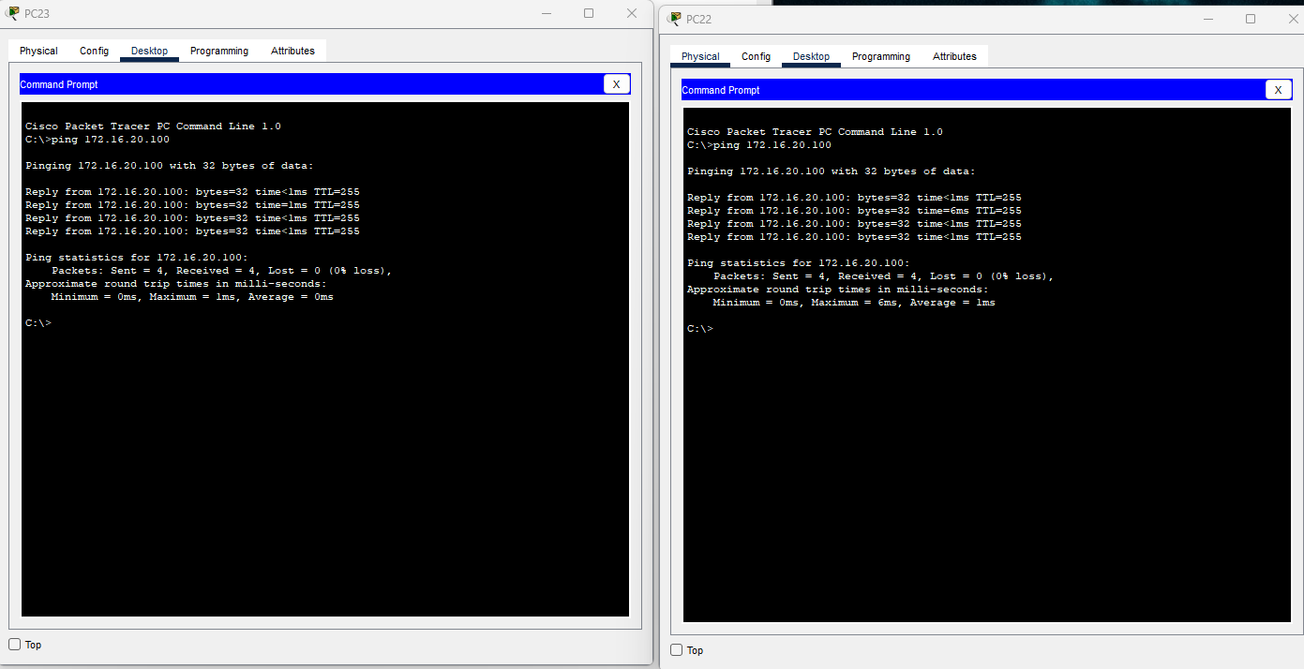

Task 7 NAT
Task 7 NAT - inside the cloud called NAT
Write the commands. It is optional to test on your PT file
Servers have ip addresses from 10.1.1.32/27. The PCs have ip addresses from 10.1.1.128/27
- PCs (but not servers) on the R-NAT LAN may access the internet using the public address on the R-NAT Gi0/0/1 interface.
Use ACL 20 to achieve this.
- An Internet_user may access the company http server (10.1.1.50) using the public address 192.1.1.50

- An Internet_user may access RADIUS (tcp, port 1812) at the company server (10.1.1.50) using the public address 192.1.1.51.

! A Configure R_NAT
PCs have internet using the public address on R-NAT gi0/0/1
access-list 20 permit 10.1.1.128 0.0.0.31
ip nat inside source list 20 interface Gig0/0/1 overload
interface Gig0/0/0
ip nat inside
interface Gig0/0/1
ip nat outside
! B Write commands but don’t configure any device
users on the outside can access the company server (10.1.1.50) using the public address 192.1.1.50
ip nat inside source static tcp 10.1.1.50 80 192.1.1.50 80

! C RADIUS (tcp, port 1812) to the company server (10.1.1.50) using the public address 192.1.1.51.
ip nat inside source static tcp 10.1.1.50 1812 192.1.1.51 1812

